Sejong Stay Reservation Form

Guest Information
First name |  |  | Last name
Nationality |  |  | Contact no.
E-mail address
Reservation
Check-in date |  |  | Check-out date
No. of guests |  |  | No. of rooms
Arrival flight No. |  |  | Departure flight No.
Room type |  |  | Special Room rate(10% V.A.T is included)
Standard Twin(Queen Bed 1ea, Single Bad 1ea)  Breakfast Buffet(Not served) |  |  | KRW 78,000/ US 71
Triple Room(Single Bed 3ea)  Breakfast Buffet(Not served) |  |  | KRW 90,000/ US 82
Room Type
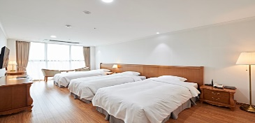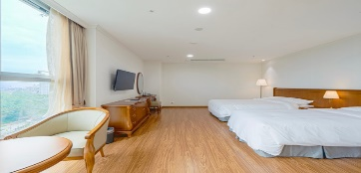

Trip Room Deluxe Room

All Non-Smoking Room
Credit Card Information
Type
Credit card no.
Card holder’s name
Expiry date (Year/Month)
- Reservations at the hotel require credit card guarantee.
Please pay in cash on arrival at the hotel. (KRW/USD)

Cancellation policy
If the event of any cancellation or change, please notify our reservation team at least 72hours prior to the arrival date. One night charge will be applied for no-show or failure of advance cancellation.
None guaranteed reservation(s) will be held 72hours prior to the guest’s expected arrival time (Seoul time). If you wish to hold your reservation(s) without any restrictions, please do guarantee your reservation by providing us with your credit card information.
Contact No.: +82-2-3408-4497 Fax: +82-3408-4660 E-mail: acetes7@sejong.ac.kr

