Curriculum Vitae
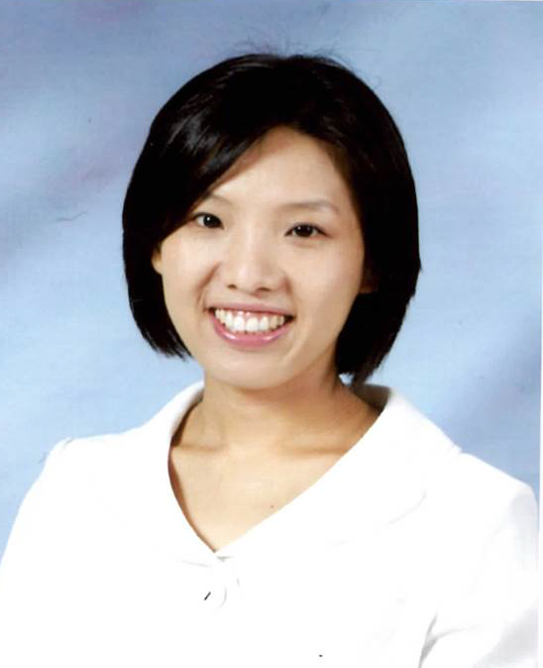

Address:
Division of Pulmonary and Critical Care Medicine,
Department of Internal Medicine and Lung Institute of Medical Research Center
Seoul National University College of Medicine
Seoul National University Bundang Hospital
166 Gumi-Ro, Bundang-Gu, Seongnam -Si
Gyeonggi-Do, 463-707, Republic of Korea

Medical Training
- 2006-2007: Intern, Seoul National University Hospital, Seoul, South Korea
- 2007-2011: Resident, Seoul National University Hospital (Internal Medicine)
- 2011-2013: Fellow (clinical and research), Seoul National University Hospital, (Pulmonary and Critical Care Medicine, Internal Medicine)

Current Position
Clinical Professor, Department of Internal Medicine and critical care medicine
Seoul National University Bundang Hospital

Editorial member, Korean Journal of Internal Medicine
Member of Training Committee, Korean Society of CCM

Board Certification
2006 Korean Medical Association Licensing Examination
2011 Korean Board of Internal Medicine
2015 Respiratory Board of Korean Internal Medical Association
2015 Intensivist Board of KSCCM

