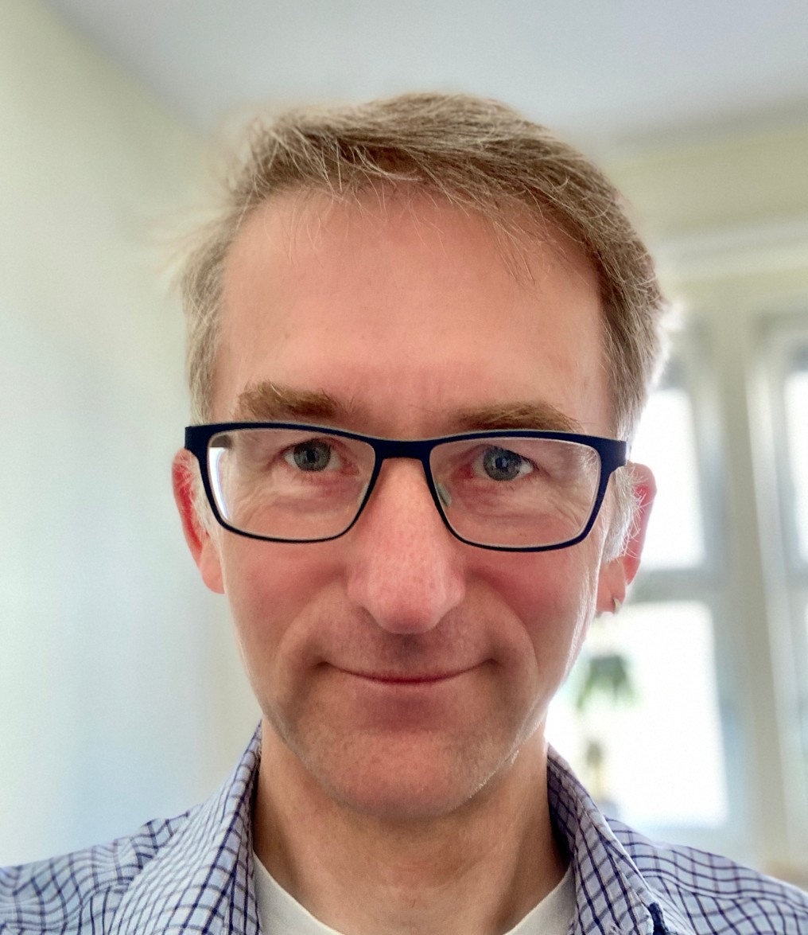Peter Nydahl

Work
Peter Nydahl, RN BScN MScN PhD
a) Nursing Research, University Hospital of Schleswig Holstein, Germany b) Department of Anaesthesiology and Intensive Care Medicine, University Hospital of Schleswig Holstein, Germany
Haus V40, Brunswiker Str. 10, 24105 Kiel, Germany

Qualifications
1990 State Registered Nurse
1994 Trainer for Basic Stimulation in nursing care
1997 Instructor for Basic Stimulation in nursing care
2006 Nursing expert for patients in unresponsive wakefulness syndrome
2007 Mentor in Nursing
2013 Bachelor of Science in Nursing
2016 Master of Science in Nursing
2020 Promotion/PhD

Employment:
1990-current University Hospital of Schleswig-Holstein, Campus Kiel
1990-1991: ward of the ear-, nose- and throat-department
1991-1996: ICU in the department of the thorax- and abdominal surgery
1996-2015: ICU and Stroke Unit of the neurological department
2015-current: ICU in the department of Anaesthesiology and Intensive Care Medicine
2012-current Nursing Research

Publications (https://orcid.org/0000-0002-5178-0364)
41 International peer reviewed publications
112 Professional publications
5 Books edited
20 Book chapters
6 Websites
14 Posters
13 Conference organization and committees

Peer review
>150 manuscripts in 40 international peer reviewed journals https://publons.com/researcher/1584447/peter-nydahl/

Societies
German Society for Specialized Care, German Society for Critical Care Medicine, German Society for Nursing Care, German Society for Neuro Critical Care, British Association of Critical Care Nurses, Int. Society for Basic Stimulation e.v., Sepsis Help e.V., Network for early mobilization,
ICU Recovery Network, international ICU Diary Network, German Delirium-Network e.V., European Society of Critical Care Medicine, Australian Society of Critical Care Nurses, Society for Critical Care Medicine

Conflicts/Prizes
2013: George Evers Memorial Prize
2018: Research grant by German Society for Critical Care Medicine and Philips
2019: Best poster by German Society for Critical Care Medicine
2019: Research grant German Society for Critical Care Medicine (Co-Author)

Kiel, February 2021

